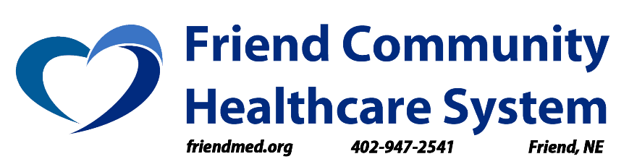
905 2nd Street
Friend, NE 68359
www.friendmed.org

_____________________________________________________________________________

FOR IMMEDIATE RELEASE CONTACT: Trey Perry
April 27, 2021 tperry@friendmed.org
402.947.2541

$2.2 Million COVID-19 Federal Grant Funds Large Renovation Project at Friend Community Healthcare System

FRIEND, NEBRASKA - Construction is underway at Friend Community Healthcare System. Our rural hospital recently received a $2.2 million COVID-19 grant from the federal government as part of the CARES Act. We’re excited to share COVID-centric updates to patient treatment areas that the hospital will gain from this project. The struggles of rural healthcare are widely known. We are certain this project will increase our capacity to provide life-saving care to our surrounding rural communities, many of which are located further from a more urban area. In emergency situations, having a healthcare option near these rural communities can mean life or death.

Upgrades that will be included in this renovation project include:

- New Patient Isolation Rooms with Air Filtration Systems and ADA Approved Bathrooms
  - This will allow for FCHS to house and treat patients suffering from infectious diseases, including COVID-19.
- Upgraded Emergency Department with Three New Emergency Bays
  - This will increase our number of Emergency Department bays from one to three, with
- New Nurses Station Located Next to Emergency Department
  - This will increase our nurses’ abilities to interact with and treat patients, as well as have a quicker response time in emergency situations
- New Patient Receiving Area/Entrance
  - This will provide a true center point for all of our visiting patients and allow for seamless customer service, direction, and distribution of information upon arrival to FCHS.

If the timeline stays true, the entire project is slated to be completed within 7 to 8 months from now, providing an enormous Christmas present to Friend and our surrounding communities.

